Use the following requirements for a Library Management System:
- Add a feature to search books by title and author.
- Implement an online book reservation system.
- Generate monthly reports on borrowed books for
- administrators.
- Enable email notifications for overdue books.
- Add support for QR code scanning for borrowing and
- returning books.
- Create a user-friendly dashboard for librarians.
- Allow users to review and rate books.
- Integrate a chatbot for user assistance.
- Develop a mobile app version of the system.
- Provide multi-language support.
Categorize each requirement using MOSCOW Method (Must-Have,
Should-Have, Could-Have, or Won’t-Have) based on the following
criteria:
- Impact on the users and stakeholders.
- Feasibility considering time, budget, and resource constraints.
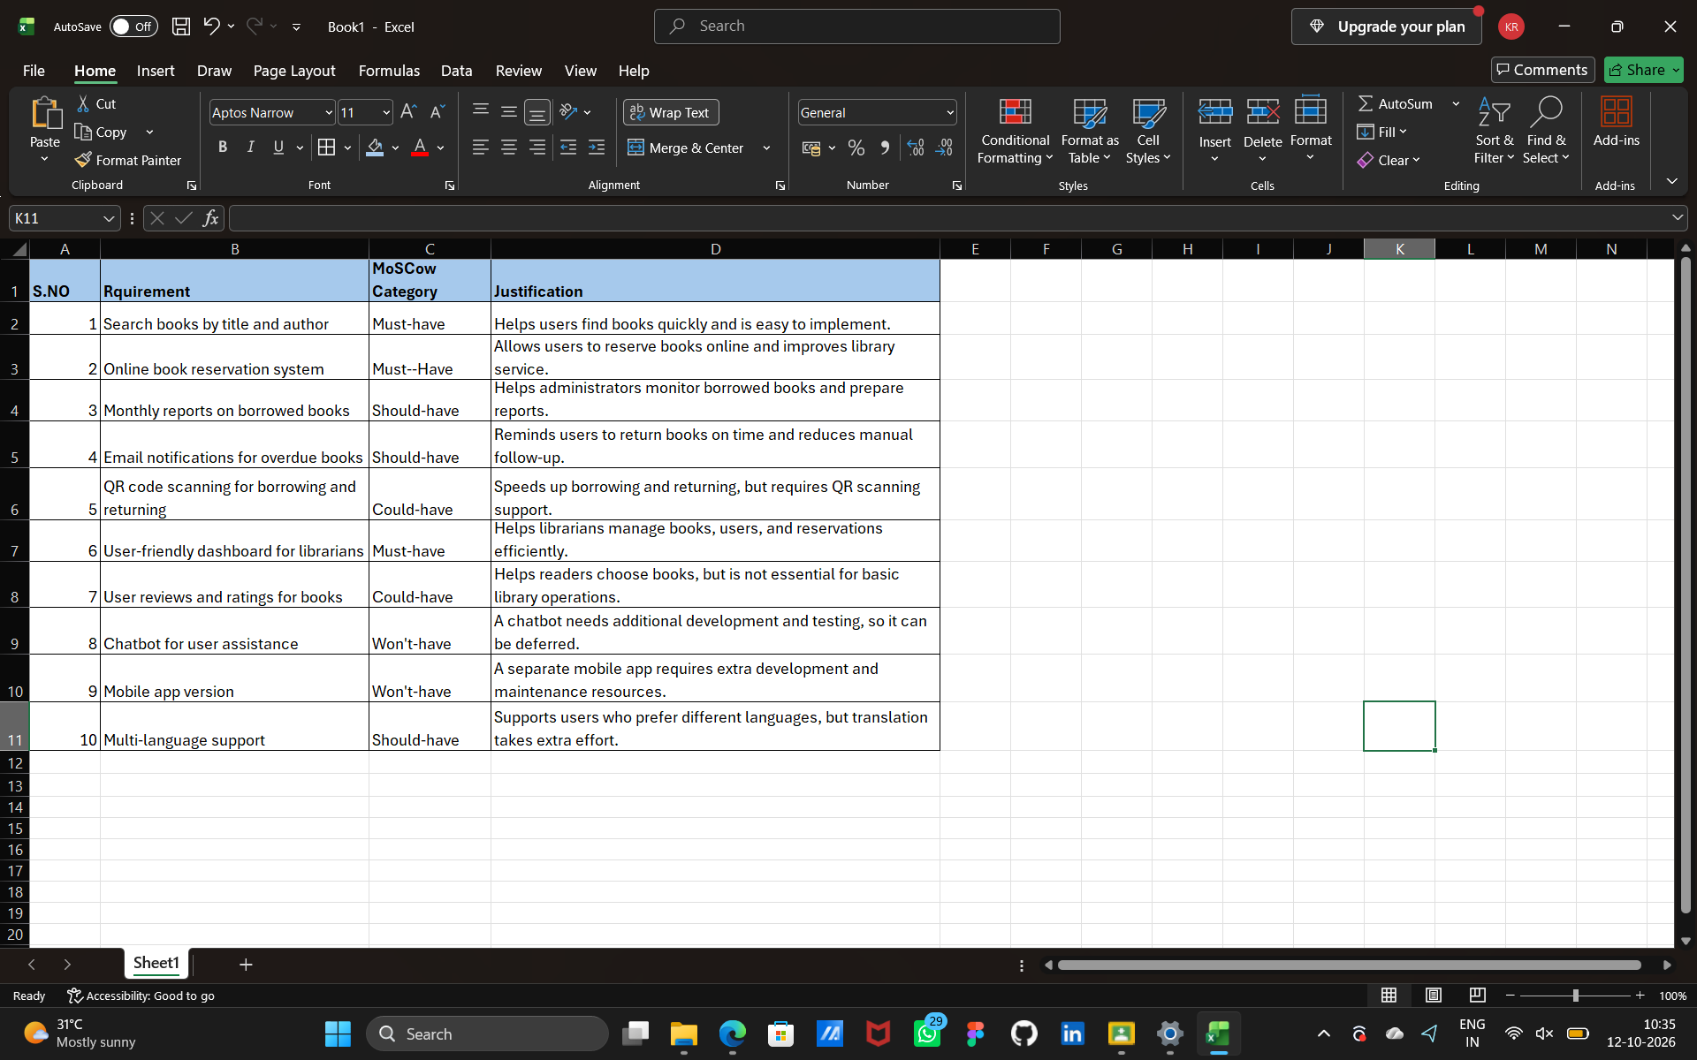
Finally Submit the completed Google Sheet or Excel file with all requirements categorized and justified.

